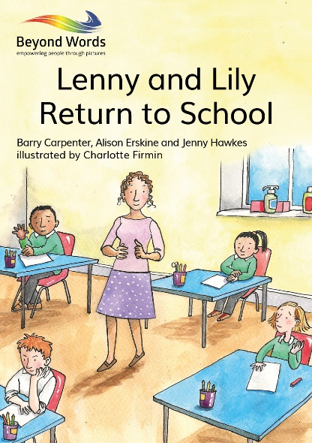
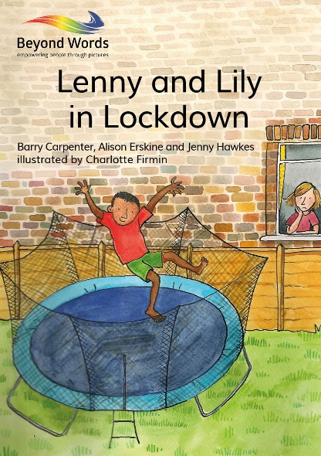

Wordless picture stories launched to support children’s mental health post-pandemic
School closures have been one of the biggest disruptions caused by the coronavirus pandemic, and for most children, lockdown has meant a loss of routine, structure, friendship, opportunity and freedom. Some may even have lost family members.
Prof. Barry Carpenter CBE and teachers Alison Erskine and Jenny Hawkes recognised that as schools reopen for the new term, supporting children to settle back into their daily school routine after such a long break and so much change will be a top priority for all teaching staff and parents.
In response, together with more than 50 primary school children – mainstream and SEN – and artist Charlotte Firmin, they developed Lenny and Lily in Lockdown and Lenny and Lily Return to School. These free wordless picture stories are specially designed to help children make sense of their experiences since lockdown began, communicate their feelings and prepare for more change as they head back to the classroom.
“Children have had their world turned upside down by the pandemic; many are angry and confused, carrying lots of unprocessed information. These books will offer opportunities for children to recall those experiences, and, in so doing tell, ‘their’ story. The books make a unique contribution to the Recovery Curriculum of any school, and to its overall curriculum work in Social, Emotional and Mental Health.” – Prof. Barry Carpenter CBE
“Following ‘lockdown’, with children now returning to their schools, teachers know that every child in their class will need time to talk. Each child’s experiences will need to be shared and acknowledged. These wordless stories are a unique way to help children recall and tell their own story of lockdown and to talk about their emotions and feelings as they return to school and begin their journey of recovery.” – Jenny Hawkes; Assistant Head, Whitfield Aspen School
“The strength of these wordless stories is the ease at which they can be used with all primary aged children. They can be used to stimulate a whole class discussion, as a small group activity or with an individual child. Lenny and Lily’s experiences are a prompt for all children to tell their own stories, regardless of their communication abilities. Adults are able to listen, acknowledge and reassure the children, helping them articulate what they are feeling and make sense of what is happening as they return to school.” – Ali Erskine; Head of School for KS1, Whitfield Aspen School
As the latest additions to the award-winning Books Beyond Words series, the stories are ideal to help teaching staff open up conversations with pupils about the things they’ve experienced and the emotions they’ve felt over the past few months. They will also be useful for parents to read with children so they can discuss any anxieties around returning to school and provide reassurance.
Beyond Words Founder and Editor, Prof. Sheila the Baroness Hollins says that the need for more books which help primary school children to explore their feelings became apparent during a two year project using existing books in the series in schools across the country.
Both stories are available to download for free in time for the start of the new term from: www.booksbeyondwords.co.uk/lenny-and-lily-childrens-stories.

NOTES FOR EDITOR
About the resources
Title: Lenny and Lily in Lockdown and Lenny and Lily Return to School
Authors: Barry Carpenter, Alison Erskine and Jenny Hawkes
Illustrator: Charlotte Firmin
Price: FREE digital download
Download link:
www.booksbeyondwords.co.uk/lenny-and-lily-childrens-stories
About Beyond Words
Beyond Words is a charity founded by Prof. Sheila the Baroness Hollins that produces books, eBooks and the BW Story App to support people who find pictures easier to understand than words.
Books Beyond Words use pictures to tell stories that engage and empower people, on themes such as love and relationships, health, death and dying, employment and even crime. The books explore feelings and relationships as well as giving information. Every book is tested with at least 50 people to ensure it is easy to understand.
The books are also a tool for professionals to use with people in many different teaching, activity and counselling situations. As well as a story told in pictures, each Beyond Words title has written information, guidelines and resources for readers, families, supporters and professionals. Elearning modules in how to use the books to best effect are offered via the Beyond Words website.
See www.booksbeyondwords.co.uk for further information.

