A LESSON IN KINDNESS:
EDUCATIONAL RESOURCES INSPIRED BY THE BOY, THE MOLE, THE FOX AND THE HORSE RELEASED TODAY

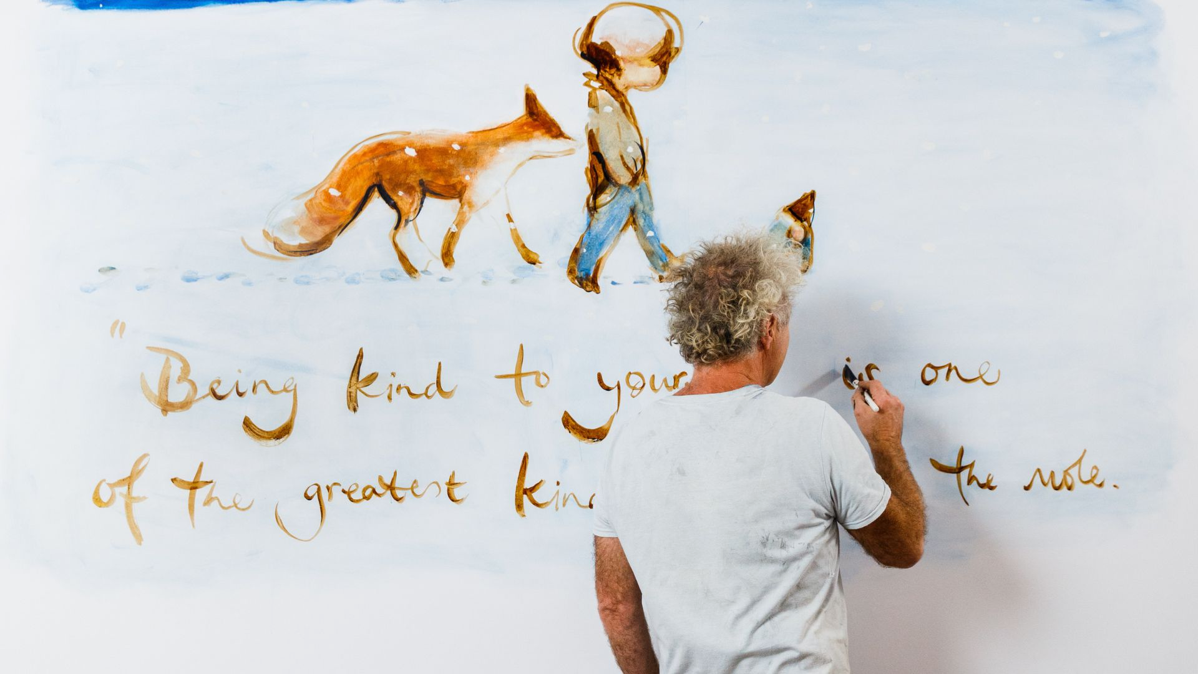

Award-winning Author Charlie Mackesy has partnered with the National Literacy Trust, Penguin Random House UK and BBC Teach to share free educational resources inspired by his beloved bestseller The Boy, the Mole, the Fox and the Horse.

Since the publication of the book in 2019, and 2022 animated film adaption, Charlie has received messages, pictures, hand-made books and drawing from teachers and children who have engaged with the story in classrooms and online platforms. In response, a collection of resources has been produced to assist teachers with their lesson plans, assemblies, and performances providing an opportunity for children to explore the messages of the book.

Together with writer and musician Charlotte Freud, Charlie has produced a musical for schools adapted from the Oscar winning animated short film currently available on BBC iPlayer. Written to be performed by children in primary Schools, a playscript, sheet music, sing-along learning videos, performance tracks and backdrop artworks will all be available for free on the BBC Teach platform from 3 November 2023. The musical play has six easy-to-learn new songs for children to perform both as soloists and ensembles – allowing groups of all sizes and ages to take part. The performance-based resource pack engages children in the book’s messages through interactive sessions.

Charlie Mackesy says “I hope perhaps it opens up the world a bit more to children, giving them a deeper understanding of the messages of the book. I hope learning the lines as simple mantras will allow them to repeat them all their lives, and stay in their hearts. I hope it gives teachers and children alike, permission to explore – feel free to do what they like – perform every word faithfully; or change some lines as they see best; leave out whole scenes or just rehearse and perform one of them; workshop it, make it different or even find themselves creating a while new play all of their own. I hope they enjoy it.”

In partnership with the National Literacy Trust and Penguin Random House UK, a resource pack including Assembly Plans and Classroom Activities for KS1 And KS2 has been made available in celebration of World Kindness Day (13th November). These resources link directly to the curriculum, in particular focusing on literacy and reading for pleasure, alongside the PSHE Association’s programme of study, and explore ways we can show kindness to one another and invite children to think about their own wellbeing.

Partner and publisher of The Boy, the Mole, the Fox and the Horse, Ebury, part of Penguin Random House UK, will also donate books to over 64 primary schools for a World Kindness Day “kindness drive”. A gesture followed by Puffin’s World of Stories team, who will be gifting over 450 copies of The Boy, the Mole, the Fox and the Horse: The Animated Story (published to accompany the animated short film) to teachers and librarians attending their regional networking sessions during November.

ENDS

CONTACT

Becky Bosworth | becky.bosworth@freud.com 07872604669
Alexandra Heybourne | alexandra.heybourne@freuds.com 07973189364

NOTES TO EDITORS

About The Boy, the Mole, the Fox and the Horse
- Published in October 2019, The Boy, the Mole, the Fox and the Horse has sold over 10M copies worldwide and holds the record for the most consecutive weeks in the Sunday Times Non-Fiction Charts across all formats. It is the longest running Sunday Times Non-Fiction Number One of all time and one of the top 10 adult books of all time. The Number One New York Times Bestseller is one of 8 books since 2013 to have remained on the list for over 200 weeks and has been translated into over 55 languages.

About The Animated Short Film of The Boy, the Fox, the Mole and the Horse
- Broadcast on BBC One on Christmas Day, the animated short film was one of the most watched programmes in Christmas week on the BBC in 2022, with over 14M views to date. The film went on to win an Oscar for Best Animated Short Film and a BAFTA for Best British Animated Short Film.

About Charlie Mackesy
- British artist, illustrator and author Charlie Mackesy began his career as a cartoonist for The Spectator, before becoming a book illustrator for Oxford University Press. His award-winning work has featured in books, private collections, galleries and public spaces around the world. He worked with Richard Curtis on the set of Love Actually to create a set of drawings to be auctioned for Comic Relief, and with Nelson Mandela on a lithograph project, The Unity Series. His internationally bestselling book, The Boy, the Mole, the Fox and the Horse, was published in October 2019. Charlie is currently working on an animated short film adaption of the book. Charlie's words and illustrations have brought comfort to many and have been shared online around the world as well as on t-shirts for Comic Relief, magazine covers, street lamp posts, school classrooms, cafés, women's safe houses, prisons, hospital wards and as NHS hospital computer screensavers. Away from art Charlie co-runs Mama Buci, a honey social enterprise in Zambia.
- Author image here - © Charlie Gray

About The National Literacy Trust
- Literacy changes everything. It opens the door to the life you want. It’s the key to knowledge, confidence and inspiration. It’s better results at school, and better jobs. If you grow up without the tools to communicate, without books to read or opportunities to write, it’s harder to get where you want to go.
- We’re a charity helping people overcome these challenges and change their life chances through the power of words – reading, writing, speaking and listening. From first words, through school days to training, jobs and beyond.
- Together, we’re helping people change their stories.

About BBC Teach
- BBC Teach is the BBC’s platform for primary and secondary school teachers, offering thousands of free, curriculum-linked classroom videos. Launched in 2018, the award-winning website is home to video content produced in consultation with experts, designed to be teacher-mediated and flexible, for communal classroom learning.
- BBC Teach is also home to spectacular Live Lessons, which celebrate special moments in the school calendar, and classroom projects including 500 Words and micro:bit – the next gen.
- BBC Teach is part of BBC Children’s and Education. For more information visit: www.bbc.co.uk/teach

